**VISVESVARAYA TECHNOLOGICAL UNIVERSITY, BELGAUM**

“Jnana Sangama”, Belgaum-590018

****

Web Technologies Laboratory

(IS6L01)

A Project Report on

“**A Bakery Website**”

*Submitted in partial fulfillment of the requirement for the award of the degree of*

**BACHELOR OF ENGINEERING**

**IN**

**INFORMATION SCIENCE & ENGINEERING**

Submitted by

**Maithreyee M S 4NI18IS042**

**Niharika Arun 4NI18IS052**

Under the Guidance of

**Monika Nag K J Faculty 2**

Assistant Professor Designation

**Dept of IS&E Dept of IS&E**

**NIE, Mysuru NIE, Mysuru**

****

**The National Institute of Engineering Department of Information and Engineering**

**MYSURU - 570008 MYSURU - 570008**

**2020-2021**

**THE NATIONAL INSTITUTE OF ENGINEERING**

**MYSURU - 570008**

**Department of Information Science and Engineering**

|  |  |
| --- | --- |
|  | **D:\Documents and Settings\Chandan\Desktop\WhatsApp_files\pp_013.jpg** |

**CERTIFICATE**

Certifies that the project work titled “**A Bakery Website**” is a work carried out by **Maithreyee M S (4NI18IS042), Niharika Arun (4NI18IS052)** in partial fulfillment for the requirements of the sixth semester BE in Information Science & Engineering prescribed by The National Institute of Engineering, Autonomous Institution under Visvesvaraya Technological University, Belagavi. It is certified that all corrections/suggestions indicated for Internal Assessment have been incorporated. The Project report has been approved as it satisfies the academic requirements in respect of the project work prescribed for the sixth semester in Web Technologies Laboratory.

Signature of Guides Signature of HOD Signature of Principal Dr. P. Devaki Dr. N.V. Raghavendra

1. Professor & Head, Principal

2. Dept of ISE, NIE, Mysore

Name of the Examiner Signature with Date



**ABSTRACT**

Nowadays, online buying is popular. People prefer internet purchasing over traditional shopping since it saves them money and time.

“Cake My Day” is an online bakery ordering system where various types of cakes are the main product to sell online. It enables the users to customize different bakery items available on the website (cakes, muffins and cupcakes).

The project comprises the list of bakery products and the users can browse and customize their order through the available list of items. If the user likes a product he may add it to his shopping cart.

Here we utilize easy to use interface to make the whole frontend. The middle tier or code behind model is intended for quick preparing. In this way, the online Bakery shopping project brings a whole bakery shop web-based, making it simple for both buyer and seller.

**Modules-**

1. **Product Categories:** The bakery products are arranged and can be viewed in categories.
2. **Custom Cake:** User may order a custom cake as per his needed flavor, size, and shape on site.

**ACKNOWLEDGEMENT**

The success and the final outcome of this project required a lot of guidance and assistance from many people and we are extremely fortunate to have got this all along the completion of project work.

#### We express our profound thanks to Dr.N.V.Raghavendra*,* Principal, NIE, Mysuru for his

#### much-needed moral support and encouragement.

We are grateful to **Dr.P.Devaki*,*** Prof. & H.O.D., Information Science and Engineering, NIE for her support and encouragement in facilitating the progress of this work.

We sincerely extend our thanks to our project Guides **Ms. Monika Nag K J, Ms. XXXXX and Ms. XXXXX** Assistant Professor in the Dept. of I.S.&E., for their guidance, technical expertise, encouragement and timely help in making this project a reality.

Also, we would like to extend our sincere regards to all the non-teaching staff of the IS&E Dept. for their timely support.

**Maithreyee M S 4NI18IS042**

**Niharika Arun 4NI18IS052**

**TABLE OF CONTENTS**

|  |  |  |
| --- | --- | --- |
| **1.** | **Introduction** | **6** |
| **2.** | **Proposed System** | **7** |
| **3.** | **Web Design** | **9** |
| **4.** | **Implementation** | **14** |
| **5.** | **Conclusion** | **15** |
| **6.** | **Future Enhancement** | **16** |
| **7.** | **Screen shots** | **17** |
| **8.** | **References** | **26** |

**INTRODUCTION**

The online purchasing system is currently one of the most significant technological developments. It also has a market size that is roughly identical to that of a normal physical market. An online shopping system is a method of providing individuals (customers) with the option of purchasing goods and services directly from the vendor in a real-time setting. Online shopping is a type of electronic commerce that uses the internet. From a business standpoint, clients frequently find things more appealing on websites since they can receive all the information they need there.

People are doing a lot of online shopping these days, and it's not just because it's convenient to purchase from home, but also because there's a lot of variety, there's a lot of price competition, and it's simple to browse for searching for any certain item. Sellers have access to a global market for their goods, which increases the number of customers and improves customer connections. In addition, web stores allow small businesses to launch their items on a global scale. The main goal of this project is to create a web-based application that allows users to customize their orders on an online platform. In other words, the project aimed at creating a virtual shop environment for users, in some handy form, which will be available to them through the internet. Although the concept of creating online shopping websites is not new in the electronic market, it emerged shortly after the World Wide Web (www).

Online Cake Ordering System is one of the most innovative ideas of this era. It will make a person’s life easier in a dramatic way. If a person wishes to buy a cake, that person just has to go to this system, select the cake, provide some important information and make the payment and the cake would be at their doorstep or any person can collect it all by themselves from the shop.

The idea is to provide each and every people out there to have a “fun” party on different occasions. The customers can order instantaneously across anywhere around the area, anywhere they want. The online cake ordering system will be computerized so that it has less paperwork to do and it will save both money and time. It will also reveal the bakery to the outside environment. So, everyone will have a win-win situation.

**PROPOSED SYSTEM**

“Cake My Day” is an online bakery ordering system where various types of cakes are the main product to sell online. It enables the users to customize different bakery items available on the website (cakes, muffins and cupcakes).

The project comprises the list of bakery products and the users can browse and customize their order through the available list of items. If the user likes a product he may add it to his shopping cart.

**The detailed description of the modules-**

**Product Categories**

 The bakery products are arranged and can be viewed in categories.

The bakery products available are cakes, cupcakes and muffins

On the homepage, there will be an option to choose one of them.

**Custom Cake-**

The user now can customize the order as per his needed flavor, size, and shape on site. The user or the customer can select the item they want. And, there are lots of categories, based on which he can select the right product.

The categories for cake are-

**Flavor**

1. Chocolate Truffle
2. White Forest
3. Black Forest
4. Red velvet
5. Orange

**Shape**

1. Round
2. Square
3. Rectangle
4. Heart

**Size**

1. 500 grams
2. 1 Kilogram
3. 2 Kilograms
4. 3 Kilograms
5. More than 3 Kilograms

**Toppings-**

1. Chocolate chip
2. Fresh fruits(mixed berries, orange wheel)
3. Rainbow sprinkles
4. Candies

Categories for cupcake are-

**Flavor**

1. Chocolate
2. Strawberry
3. Red velvet

**Size**

1. Small
2. Large

**Quantity**

1. 6 cupcakes
2. 12 cupcakes

**Toppings**

1. Chocolate chip
2. Fresh fruits(mixed berries, orange wheel)
3. Rainbow sprinkles
4. Candies

Categories for muffin are-

**Flavor**

1. Chocolate chip
2. Blueberry
3. Apple cinnamon
4. Walnut and coffee

**Size**

1. Small
2. Large

**Quantity**

1. 6 muffins
2. 12 muffins

**Toppings**

1. Chocolate chip
2. Fresh fruits(mixed berries, orange wheel)
3. Rainbow sprinkles
4. Candies

**WEB DESIGN**

The homepage has five menu buttons, namely, Home, About Us, The Team, Client Review and Contact Us.

Client Review

The Team

About Us

Home

Contact Us

Make Muffin

Make Cake

Make Cupcake

This page is an entry point to the Cake My Day website. The page provides links to other pages.

About Us

**Fig1.** The About Us page provides details about motto of Cake My Day and how it came into existence.

Client review

**Fig2.** The client’s response is a mirror of our great results, personable service, expert knowledge, and on-time delivery. The page provides some testimonials.

Send message

Contact us

Send

**Fig3.** The Contact Us page is for the visitors to reach out to Cake My Day personnel. The page contains one or more of the following items: an e-mail address, a telephone number, and a postal address. A visitor may also type their queries.

The Team

**Fig4.** The Team page is where visitors get an idea about the members behind Cake My Day. We see a lot of portraits and names, but the catchy pages are the unique ones that introduce their team proudly, which is what our Team page provides.

Login Page

Username

Login

Password

Create new account

Username

Password

**Fig5.** The login page allows visitor's identification and authentication, regularly performed by entering a username and password combination.

Register

Email-ID

Password

Re-enter Password

Register

**Fig6.** Registration page is used to create a user profile.

Make Cake

Option 1

Option 2

Option 3

Option 4

Make Cupcake

Option 1

Option 2

Option 3

Option 4

Make Muffin

Option 1

Option 2

Option 3

Option 4

**Fig7.** The Make Cake/Make Muffin/Make Cupcake page allows the visitor to customize their dessert with options to choose such as flavor, size, toppings, and shape.

**IMPLEMENTATION**

Having an online food ordering system for a bakery comes with its own set of benefits. One important benefit is that there are no commissions paid to third-party food aggregators. You will have your own bakery website as well as a mobile app. This will allow you to better exhibit your brand. There will be no limits or guidelines to which you must adhere.

The main objective is to make the system so simple that, with a few clicks, you may update and modify your bakery's menu as needed.

In this paper, the system is implemented on a Windows system and the

HTML and CSS language is used for design of the website. The overall requirements of hardware and software for the implementation are listed in table.

|  |  |  |
| --- | --- | --- |
|  | Elements | Options |
| Hardware | CPU | Intel Core i5 |
| RAM | 64 MB |
| Secondary Storage | 10 GB |
| Software | Operation System | Windows 10 |
| Browser | Google chrome or Mozilla Firefox |
| Programming language | HTML and CSS |

We recommend creating a one-page user guide to help users navigate the Cake My Day website easily and efficiently.

**CONCLUSION**

Currently, the largest market for this (online shopping) business is made up primarily of highly educated people. This system was created with all of the factors in mind, including data loading, complexity, and ensuring the security of user credentials. In this system, complexity refers to the overall number of functions available to users, as well as the ease with which they must be organized and used.

Both the bakery owners and users can use the E-Bakery Shop System to improve their effectiveness and reduce costs. Predicting properties like Sale More and Sale Less, based on the area of particular products sold more every day, according to the most selling products in months and years based on the respective season/period. This will enhance efficiency, save time and cost for the bakery owner. The customer will also benefit in searching for a product from different bakeries and buying the very best products from the best bakeries with their own appropriate costs based on the rating and product availability.

To conclude the features of our website;

The website will-

1. Display all of the accessible shopping categories on the home page.
2. Display all of the subcategories linked with a specific item.
3. Enables customers to personalize cakes, muffins, and cupcakes

**FUTURE ENHANCEMENTS**

As a future upgrade, we intend to incorporate a screen reader as well as Alt+text (image descriptions) for visually challenged visitors.

We intend to provide notifications and offers on special days for registered users.

We intend to use responsive design so that the website is easily accessible on all smart devices.

We also propose to add more features to the proposed system to aid both the bakery owner and customers like connecting with database so that the visitor’s data can be maintained on a database which also helps in keeping track with the visitors and their orders.

**SCREENSHOTS**

**Login Page**

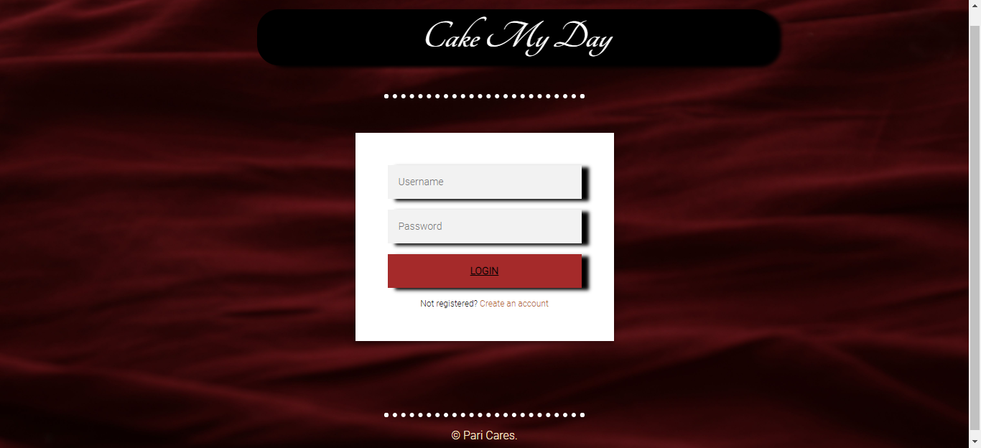

**Registration Page**

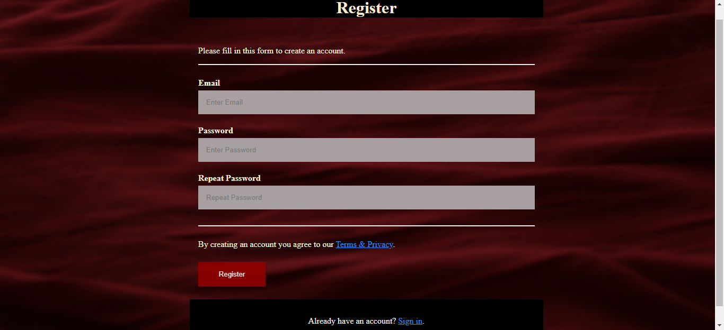

**Home Page**

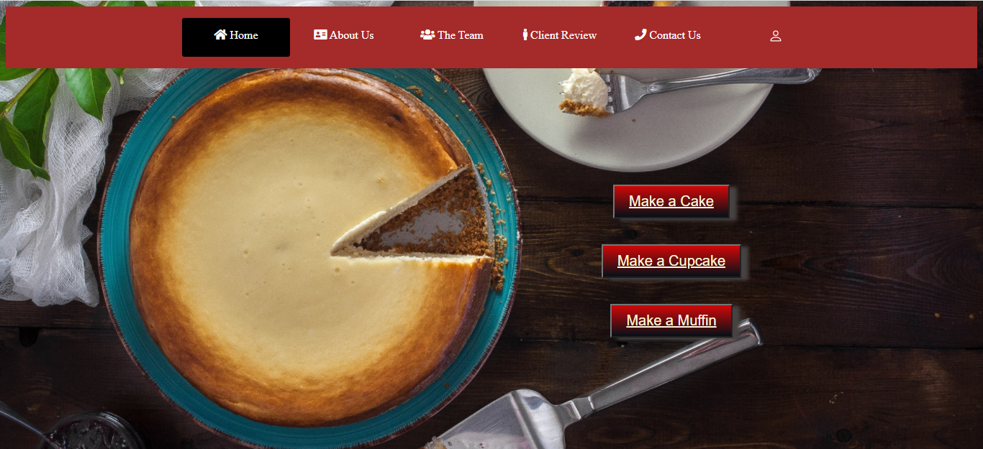

**Mission Vision Page**

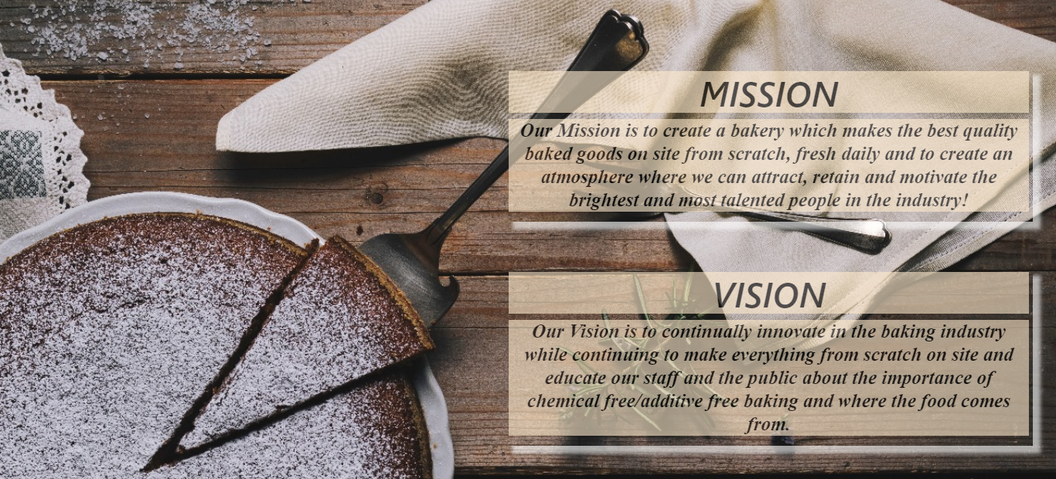

**The Team Page**

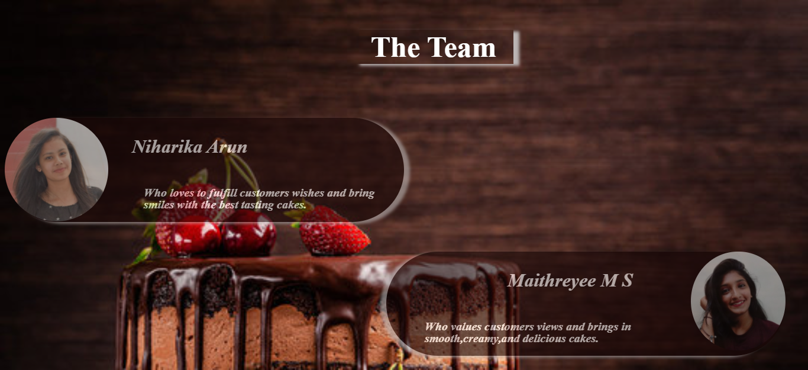

**Client Review Page**

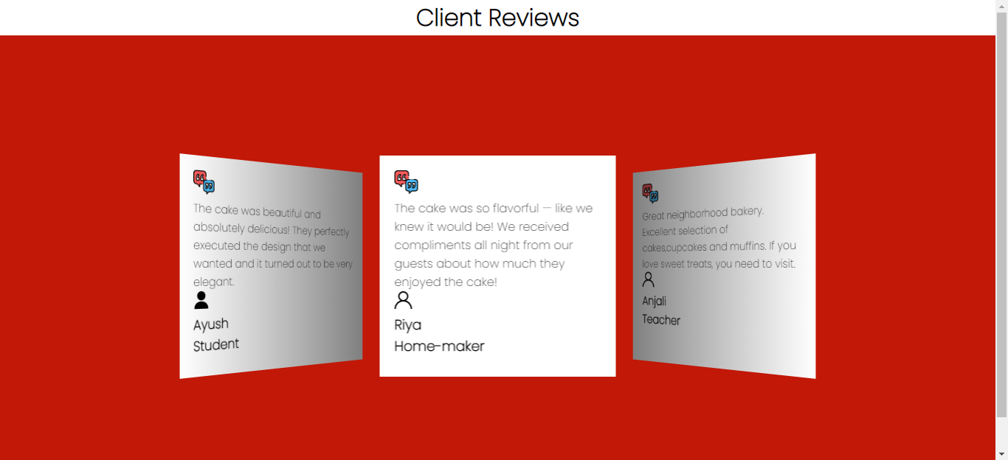

**Contact Us Page**

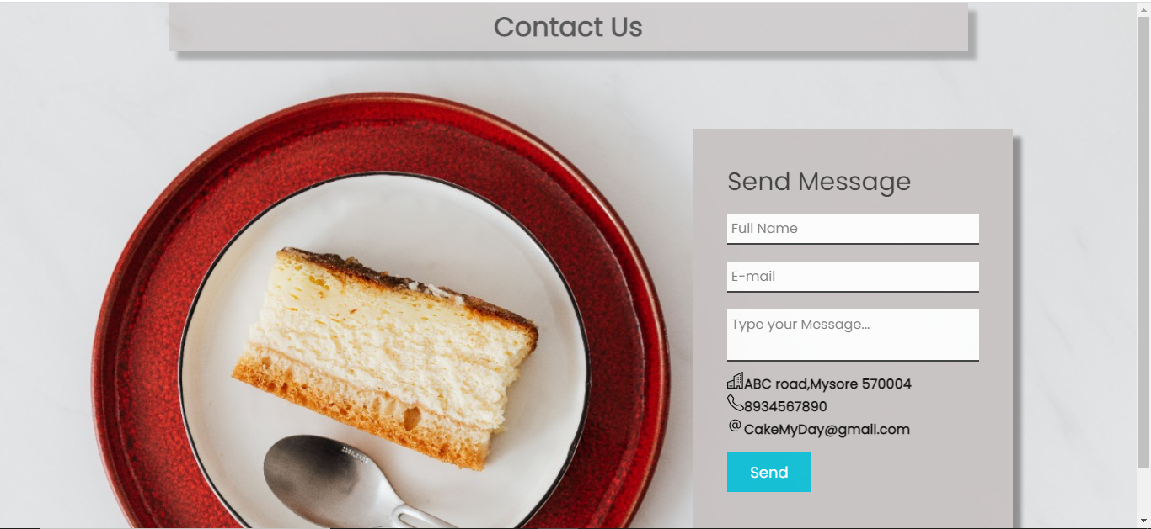

**Make Cake Page**

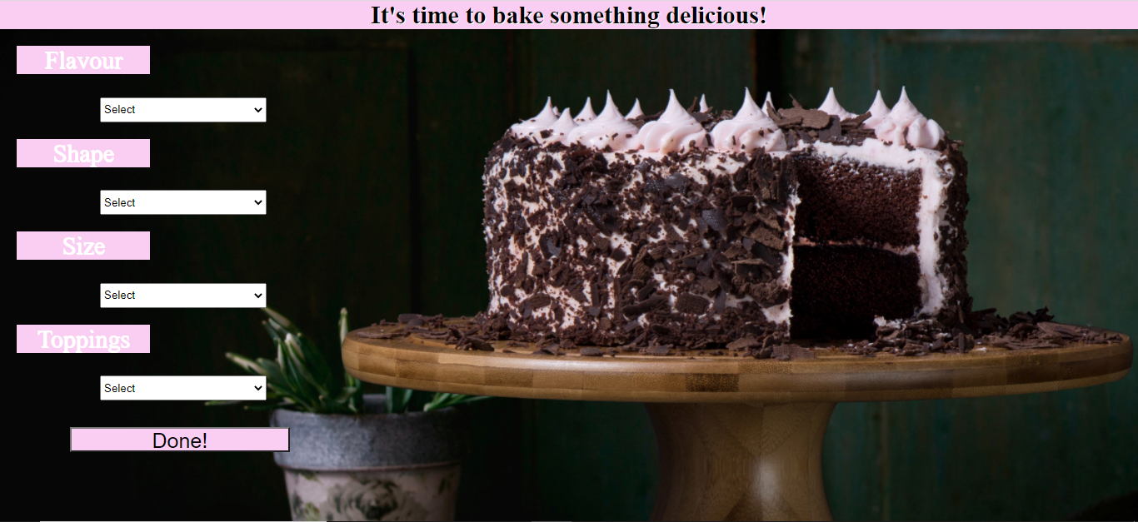

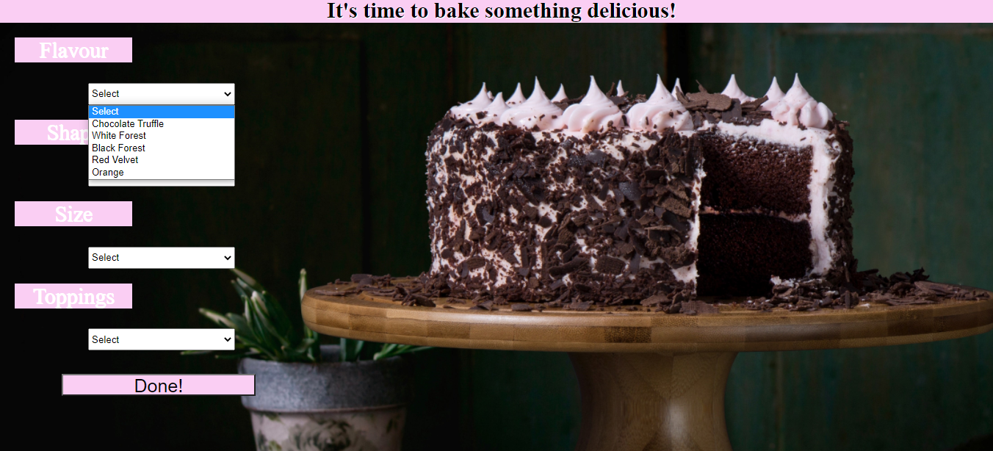

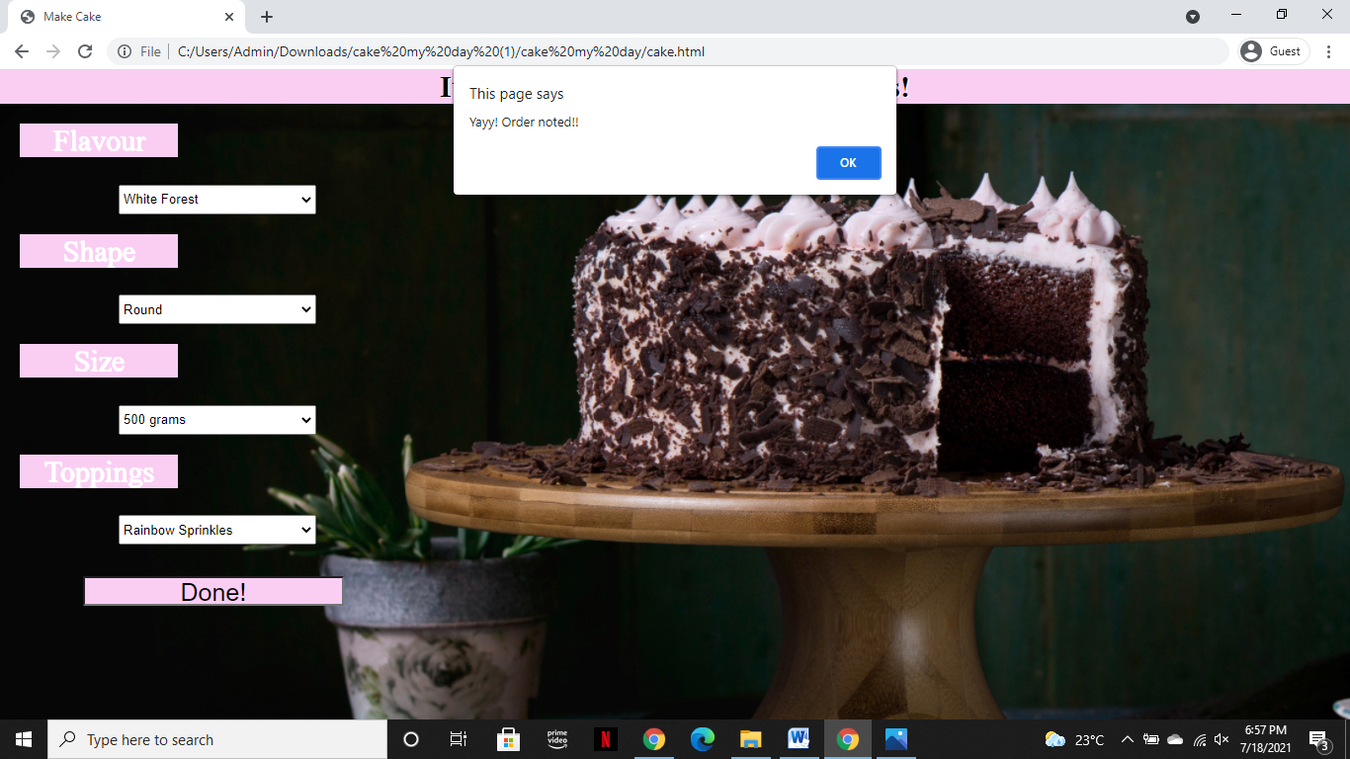

**Make Cupcake Page**

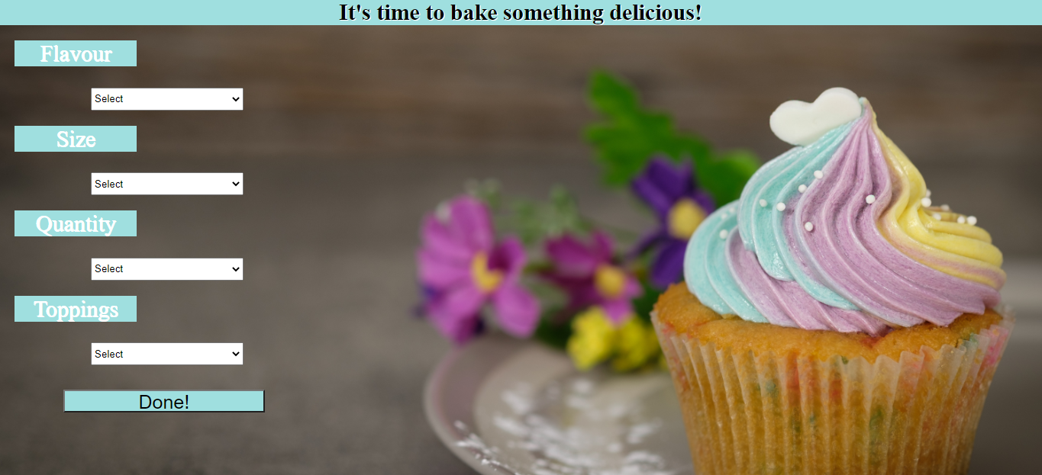

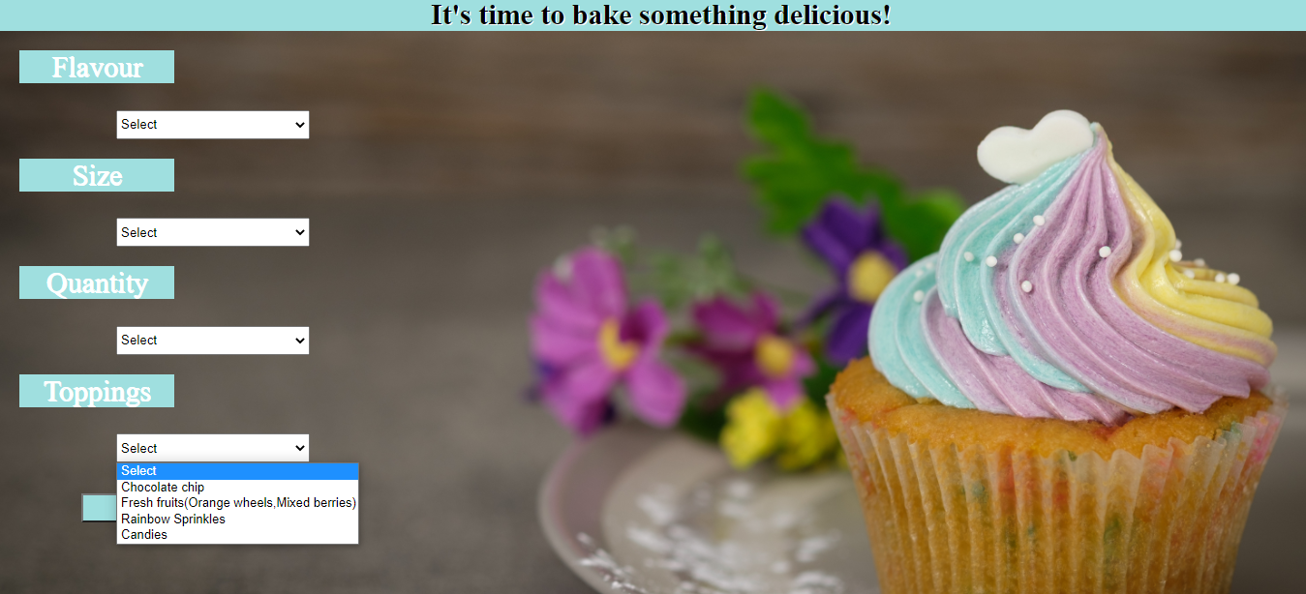

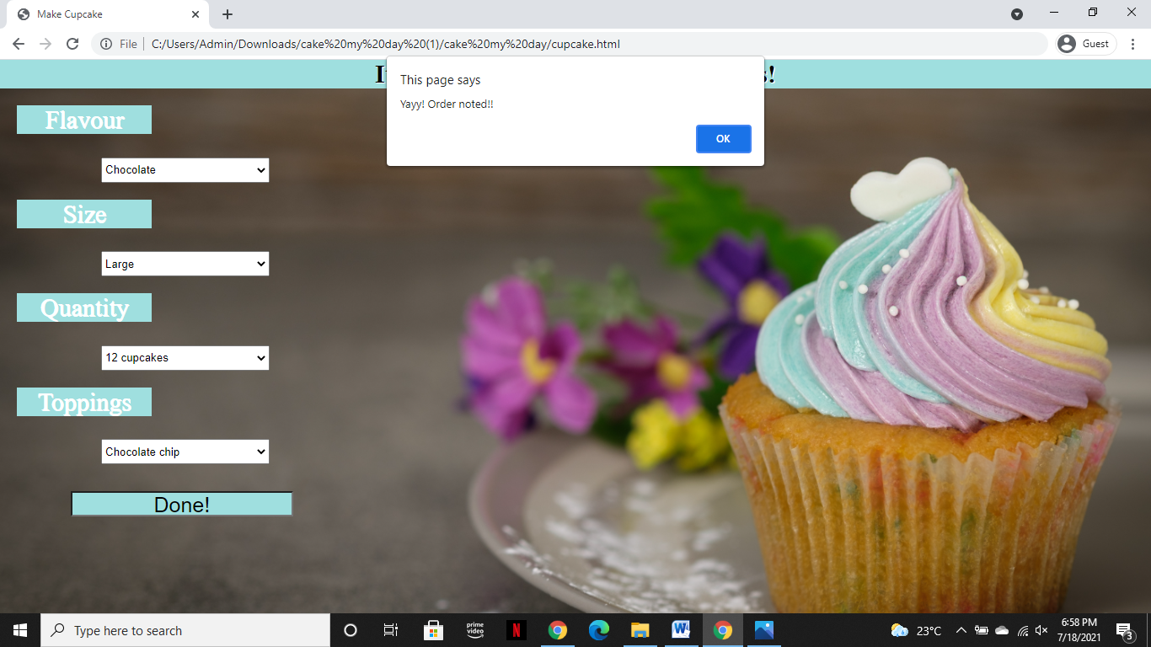

**Make Muffin Page**

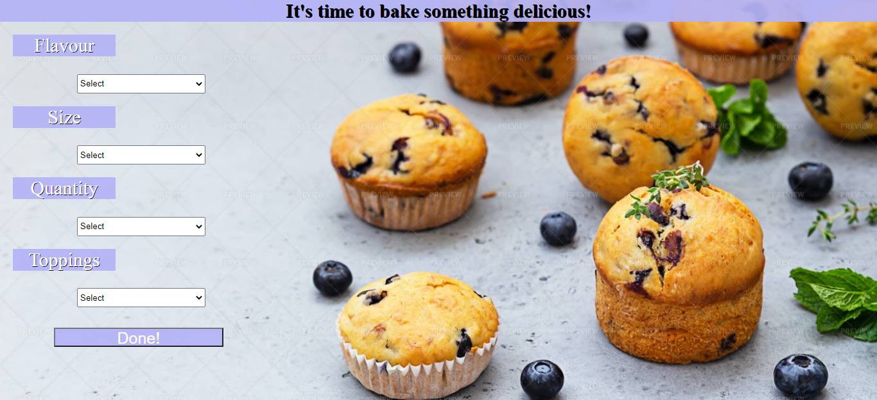

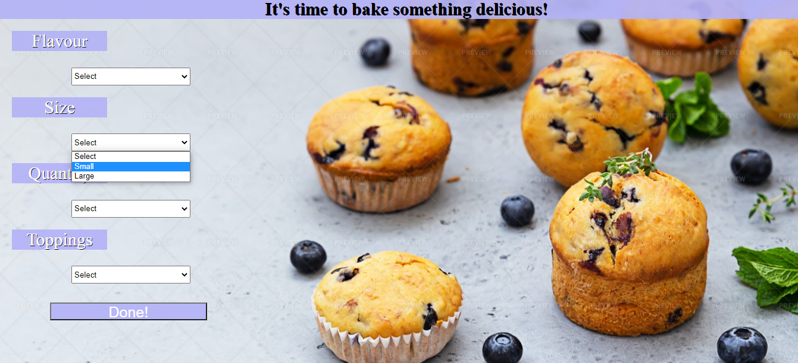

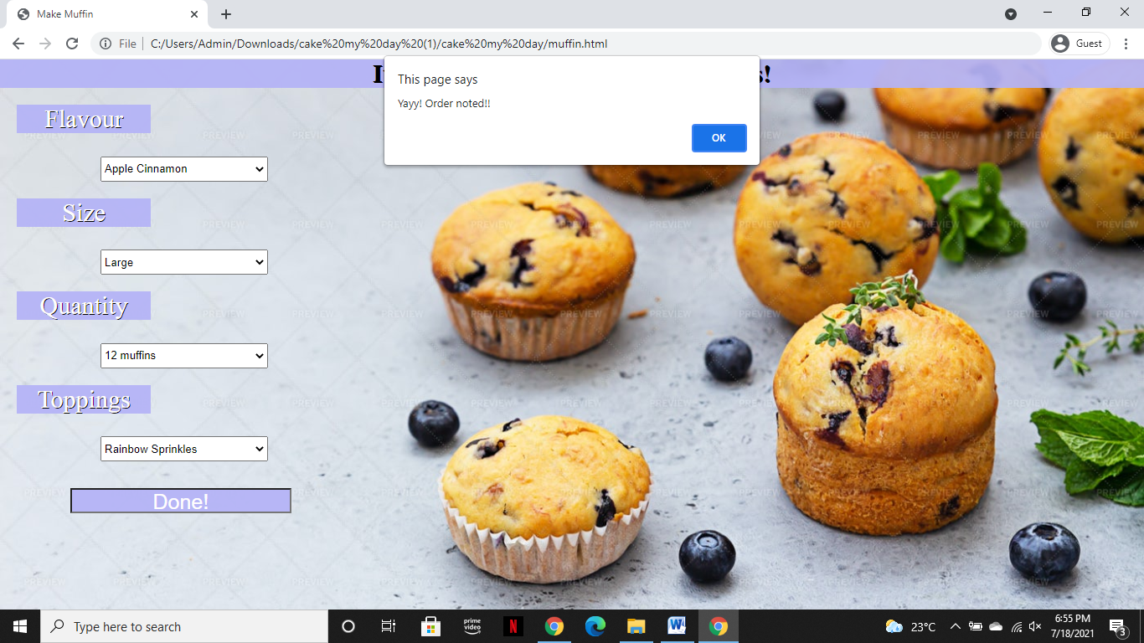

**REFERENCES**

W3 Schools- <https://www.w3schools.com/>

Code Pen - <https://codepen.io/>

You tube- <https://www.youtube.com/>